WEB CONTENT

ReSoK GF PTLD

The Respiratory Society of Kenya is supporting the Ministry of Health, through the Division of National TB, Leprosy and other lung diseases, to address the challenges faced by individuals affected by Tuberculosis (TB).
Through a grant from the Global Fund to fight AIDS, TB and Malaria, the Division of National TB, Leprosy and other Lung Diseases in partnership with the Respiratory Society of Kenya and other stakeholders is piloting a program of support to those with post-TB disabilities.
The project is currently being implemented within Nairobi County in 15 high burden sites. The key Initiatives are: -
- To expand the effort to provide appropriate care to people with post TB
lung disease and other forms of post TB disability by implementing a set of
interventions
- To build the capacity of health care workers in managing PTLD
- To fight stigmatisation of persons with PTLD through support
- To address the social economic impact suffered by the PTLD patients by
rehabilitating them to their economic potential.
- To mainstream ideal models at the community (guidelines, SOPs, relevant
equipment, and essential medicines) to manage PTLD at all levels
- To advocate for resources for continued research and management of PTLD
- Establish routine recording and reporting systems for post TB lung diseases and other chronic lung diseases

Photos;

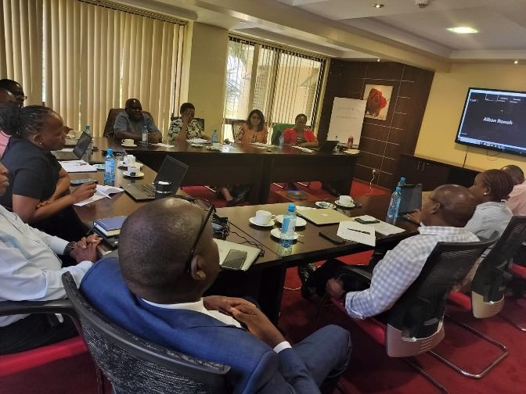
Briefing and debriefing meeting with GF team at Waridi paradise Hotel in March 2024
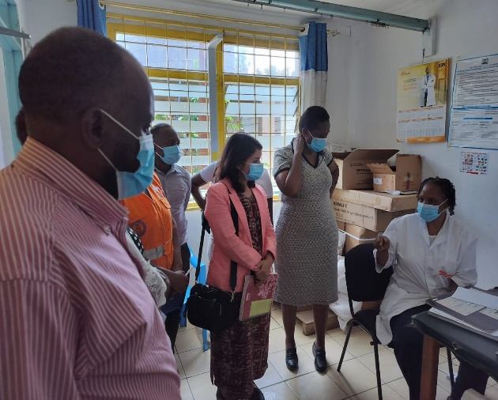
Site visit by GF team in one of the PTLD sites.

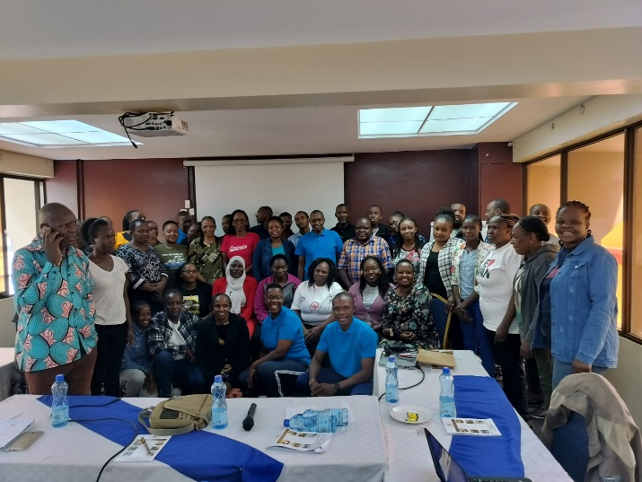
Participants posing for a photo after a five-day pulmonary rehabilitation
training at The Clarion Hotel in April 2024

